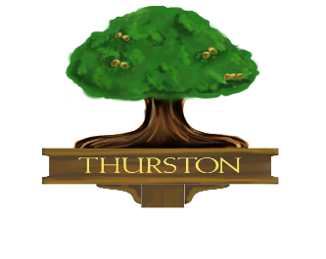
THURSTON PARISH COUNCIL
Parish Council Office
New Green Avenue
Thurston IP31 3TG
Tel: 01359 232854
e-mail: info@thurstonparishcouncil.gov.uk
website: http://thurstonparishcouncil.gov.uk

Environment and Biodiversity Photo Competition
Please complete this form either by typing your answers in Word or by printing the form and writing clearly in the response spaces provided. Where a choice is required, type or write your answer next to the prompt. This form must be submitted by email, along with your photograph.

Section A - Entry Form – Please complete this form for submission with your photograph

Theme: | Environment and Biodiversity Photo Competition
Closing Date: | 30 September 2026

Section B - Entrant details

Full name: | Answer:
Age category: | Answer: write or type one option — 14 years and over or Under 14
If under 18, parent’s or guardian’s name: | Answer:

Section C - Photograph Details

Photograph title: | Answer:
Send your entry form and photo to: | projects@thurstonparishcouncil.gov.uk
Where was the photograph taken? | Answer:
Why did you choose this subject? Maximum 100 words. | Answer, maximum 100 words:

Section D - Declaration

Declaration statement | Response
I confirm that this photograph was taken by me. | Answer: Yes or No
I confirm that the photograph was taken within Thurston. | Answer: Yes or No
I confirm that the photograph does not include any domestic pets. | Answer: Yes or No
I have read and agree to the Competition Terms and Conditions. | Answer: Yes or No
I give permission for the organisers to use my photograph for exhibitions, publicity, websites, social media and other promotional material relating to the competition and future environmental or community projects, with appropriate credit. | Answer: Yes or No

Section E - Signature

Please complete this section if you are signing as an adult entrant aged 18 or over.

Entrant’s signature: | Answer: type your name if completing electronically or sign here if printing.
Date: | Answer:
Email address: | Answer:
Contact number: | Answer:

Please complete this section if you are signing on behalf of an entrant aged under 18.

Parent/guardian consent statement: | I am the adult identified in Section B as the parent or guardian. I understand the above request and give informed consent for the holding of personal data.
Signed: | Answer: type your name if completing electronically or sign here if printing.
Date: | Answer:
Email address: | Answer:
Contact number: | Answer:

I understand the Council will keep all of the data and images in accordance with data protection law and delete the images that have not been used for any purpose after five years. I know I have the right to withdraw consent at any time by emailing clerk@thurstonparishcouncil.gov.uk but understand that withdrawing consent may not affect the material that has already been used.

For office use only | No entrant action required.
Entry number: Answer: | Date received: Answer:
Category: Over 14 / Under 14. Answer: | Eligible: Yes / No. Answer:
Judge’s score: Answer: | Notes: Answer:

